**Automatic Multi-Class Mask Generation Based on Sentinel-1/2 Derived Indices and Deep Learning Neural Network**

|  |  |
| --- | --- |
| Falah Fakhri  Independent Researcher*  [falah.fakhri@outlook.com](mailto:falah.fakhri@outlook.com)  *Corresponding author | Marco Peters  Software Engineer (EOMasters)  [marco@eomasters.org](mailto:marco@eomasters.org) |

# Abstract.

Accurate land cover classification is essential for environmental monitoring, urban planning, and agricultural management. However, existing methods often require extensive manual labelling and struggle to capture the complexity of diverse landscapes. This research introduces an automated approach for multi-class mask generation, leveraging Sentinel-1/2 satellite data and deep learning to improve the accuracy and efficiency of land cover classification.

The presented method begins with the construction of a vector classifier using threshold-based classification to combine individual spectral indices. This enables the automatic identification of different land cover types and the generation of a labelled multi-class vector dataset. The resulting shapefiles serve as robust training datasets for deep learning models.

The multi-class vector data is subsequently employed in a deep learning pipeline utilizing an Attention U-Net model as a base model such as Attention ResUnet, VGG Attention ResUnet, or/and transfer learning model however, in this study only attention U-Net is applied. This model is designed to enhance segmentation accuracy by incorporating attention mechanisms that focus on relevant spatial features in the input data. After reprojection and rasterization of the created label data, training patches are extracted from the rasterized labels and corresponding input raster. These patches are used to train the Attention U-Net model for multi-class segmentation. The model, compiled with the Adam optimizer and trained over multiple epochs, is evaluated using accuracy and loss metrics, the loss and accuracy for training and validation data were loss 0.0372, validation loss 0.0266 and accuracy 0.9846, validation accuracy, 0.9892 respectively. This is providing an efficient solution for large-scale environmental analysis and land cover classification.

# Introduction

Remote sensing has gained benefit in the humanitarian sector because it offers an unbiased, verifiable source of information that facilitates both gradual change tracking and prompt emergency response. [1]. This is particularly important when there are hurdles to field observations, such as financial limitations, legal restrictions, or security concerns. [2,3,4].   
Along with its crucial role in humanitarian response to natural disasters or emergencies [5, 6], space observation of specific locations also plays a role in improving the understanding of the region and the ways in which trends and temporal dynamics have shaped the spatial patterns of the present [7, 8]. Because it emphasizes the information in context and improves the interpretability of the retrieved information, this temporal element is frequently more valuable than the degree of spatial detail of the images alone [9].

This project aims to develop a semi-supervised classification framework designed to automatically generate high-quality masks or labels for use as training and ground truth data in multi-class semantic segmentation models. The primary goal is to enhance the precision of time series analysis and land use/land cover (LULC) classification through the integration of Deep Learning (DL) and Machine Learning (ML) methodologies. A secondary objective involves the assessment of spatiotemporal changes in biodiversity within Mosul Park and the examination of hydrological and ecological influences exerted by the Tigris River over a nine-year period. Mosul Park and its surrounding landscape serve as the core study area and primary data source for this research.

## Study area

Mosul Park, commonly referred to as "Forest Park," is an important centre for biodiversity and entertainment. It is situated in the northern region of the city. Just a short distance north of the city centre, this park is found on the eastern bank of the Tigris River. The area is nine square kilometres. One of the biggest parks in Iraq, this vast green area is a major recreational destination for Mosul locals as well as those from the neighbouring areas (Fig. 1).

Mosul is the capital of Ninawa province, a major city in northern Iraq. Located approximately 400 km north of Baghdad, Mosul stands on the west bank of the Tigris, opposite the ancient Assyrian city of Nineveh on the east bank. The metropolitan area has grown to encompass substantial areas on both the “Left Bank” (east side) and the “Right Bank” (west side), as the two banks are described by the locals compared to the flow direction of Tigris.

Fig. 1 Mosul Park, commonly referred to as “Forest Park”.

## Data

As indicated in the previous studies and reports, the study area was subjected to rapidly devastation in short period [12].

Optical and radar remote sensing data are increasingly used for Land use\Land cover mapping and monitoring, their technical capabilities and tools are improving all the time and provide more accurate results [13, 14].

To enhance the capabilities of biodiversity monitoring and change detection, and to assess the performance of the developed classification algorithm, both Sentinel-2 optical and Sentinel-1 synthetic aperture radar (SAR) datasets were selected, post-processed, and derived spectral and radar indices were generated. These data served as inputs to the newly developed semi-supervised classification algorithm, termed the *Progressive Classifier (PC)*, which is currently in its initial implementation stage and undergoing experimental validation. Hence, in order to take all these challenges into consideration, and prevent the deduction of false conclusions, SAR image S1 of Level 1 Ground Range Detected (GRD) were collected. In addition, optical data S2 between 2017 and 2023 were acquired [10, 11].

## Overall study design

### The workflow of the study is shown in Fig. 2, with each component explained in the following sections on classifier design. A brief outline of the methodological framework includes S1 and S2 satellite imagery as primary data sources for obtaining spectral and radar-based indices. These indices were subsequently integrated into a semi-supervised classification framework. The Copernicus Data Space Ecosystem (CDSE) [15] was employed for the post-processing of S1 and S2 imagery, facilitating the construction of an extensive feature space tailored to the requirements of the semi-supervised Progressive Classifier (PC). This classifier is designed to capture diverse terrestrial surface characteristics through high-dimensional spectral-radar information fusion. Upon generation of the feature space, a labeled training dataset was applied to the input variables to produce annual land cover classification maps, with the resulting outputs presented as vector masks. It is important to note that the classifier is currently under active development; thus, the results presented herein remain experimental in nature. The classification model is primarily driven by multi-layered raster-based spectral input data.

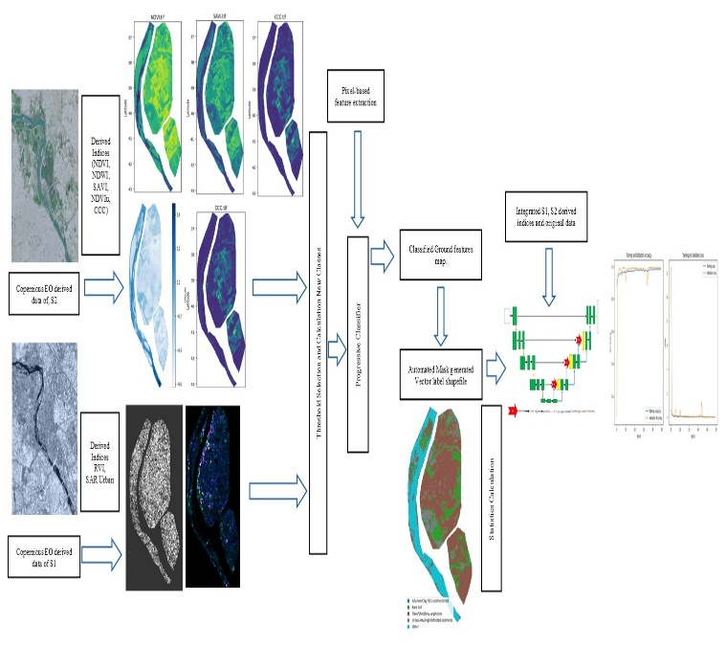

Fig. 2. Overall workflow of the *Progressive Classifier (PC).*

### Classifier design

The classifier is considered a semi-supervised classifier. It utilizes different combinations of spectral indices, with the number and type of indices varying according to the targeted classes intended to be detected. For example, if the target classes are related to water features, the selected indices are primarily those that are sensitive to water. The underlying concept is that each spectral index is calculated based on different combinations of wavelength bands, and therefore, a single index may not be sufficient to capture the full range of variation. Using a combination of indices provides a more comprehensive detection capability.

In this study, the focus was on detecting various ground features such as vegetation, water, urban areas, soil, and sparse vegetation. Accordingly, different combinations of indices were selected based on extensive experimental testing. Each ground feature is characterized by a specific minimum and maximum value range, which was determined through pixel-based feature extraction, relying on both optical and radar-derived indices.

A key question is: How does the classifier work? Please refer to Fig. 2 for details. The first step is to define the classification objectives whether to detect only water, soil, geological features, or a combination of different ground features. The second step is to select the appropriate index combinations, which are already predefined, along with their corresponding thresholds for each object. In the third step, each spectral and radar index is initialized separately. Once the combinations are ready, the fourth step involves generating the final classes, where each class represents a predefined object.

The next step of the classifier, known as the pre-final step, involves generating the vector label mask and calculating the area for each class. A table is subsequently produced, as illustrated in Table 1, which displays seasonal variations across five user-defined classes based on prior knowledge of the Area of Interest (AOI). These class names may also be anonymized using numbers or letters. In this case, the classes were Alluvium, Bare Soil, Trees and/or Shrub Vegetation, Urban Area/High Reflected Sediments, and Water. Fig. 3 illustrates the classified features for a selected date. Fig. 4 presents a different study area to demonstrate the robustness and generalizability of the classifier in accurately labelling land cover classes and aligning them with corresponding ground truth data.

Table 1. Class ID, Name and area of the generated classified vector.

Fig. 3. Classified features of the Mosul park selected date.

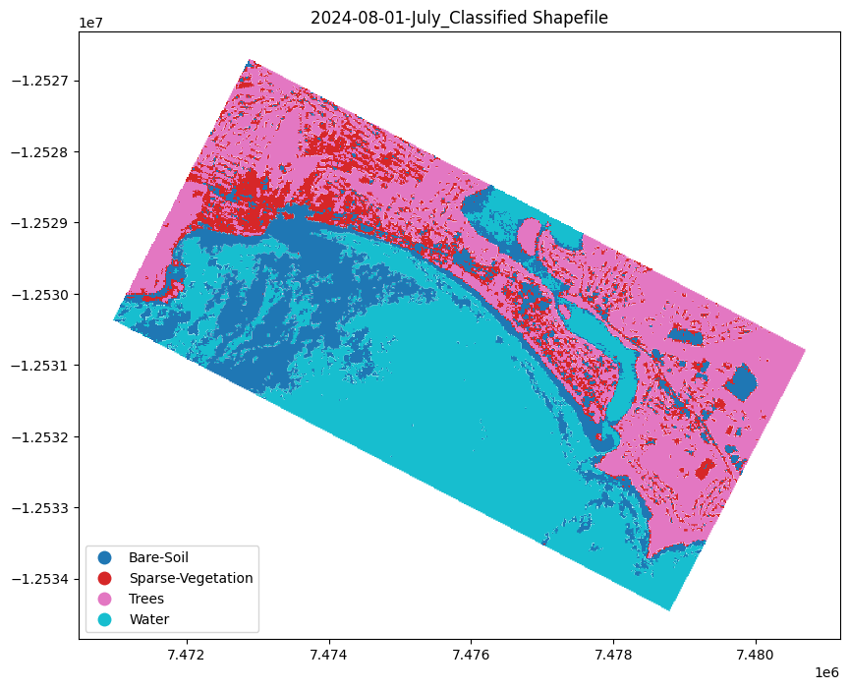

Fig. 4. Classified features of the Narrabeen Beach Sydney Australia selected date.

The final step involves integrating the stacked original S1 and S2 layers, along with the derived indices, into supervised DL/ML segmentation models. In this study, Attention U-Net was selected as the base architecture refer to Fig. 5. to perform both single-class and multi-class segmentation tasks. This approach significantly enhances efficiency by automatically generating segmentation masks, thereby reducing the need for intensive manual annotation. The proposed workflow provides a robust capability for automated and accurate segmentation of diverse ground features.

Fig. 5. Schematic architecture of Attention U-Net encompasses Attention gates and the mask and predicted multi-class semantic segmentation.

# Results and discussion

## Classification results and biodiversity

A time series of S1 and S2 data was compiled to assess biodiversity changes in Mosul Park over a seven-year period, as well as to evaluate the performance of the newly developed Progressive Classifier PC. As illustrated in Fig. 3, results from various months reveal the park’s ecological vulnerability, which is further corroborated by additional yearly datasets that will be made available via the GitHub repository <https://github.com/falahfakhri-Iraq/Semi-supervised-classification-algorithm-Progressive-Classifier-PC-> . The findings indicate that the park is ecologically endangered, characterized by the absence of perennial forest vegetation and the dominance of shrubland and seasonal plant cover both of which are strongly influenced by the availability of water and rainfall. The observed monthly and inter annual dynamics reinforce the conclusion that perennial forest species are lacking.

The classifier, though still under development, achieved an overall accuracy of 0.90, reflecting a promising level of performance. The selection of a dynamic and environmentally variable study area over multiple time intervals further validates the classifier’s sensitivity to land cover changes and its ability to detect subtle shifts in ecological patterns.

As shown in Figure 6, third-degree polynomial models exhibited the highest correlation when modelling individual land cover classes for a selected date. Additionally, Figure 7 presents the confusion matrix, which visualizes the inter class relationships and highlights the influence of water availability on vegetation growth, as well as the inverse relationship between bare soil and vegetated areas.

Fig. 6. Demonstrates that polynomials of mostly third degree for each individual ground cover of the selected date.

Fig. 7. Confusion matrix, along with the obvious effects of water on the vegetation and the relationship between bare soil and vegetated area.

# Conclusion

This study introduces a methodology for monitoring biodiversity changes in Mosul Park, centred around the development and application of the Progressive Classifier and a classification-based change detection technique. The primary motivation for selecting a dynamically changing environment was to rigorously test and refine the capabilities of the newly developed classifier. The Progressive Classifier demonstrated robust performance in distinguishing between complex and often overlapping land cover classes most notably between bare soil and vegetation, which is traditionally a challenging task. The integration of S1/S2 datasets significantly improved the model’s accuracy in mapping biodiversity changes. However, it was observed that certain radar-based indices, such as the Radar Vegetation Index RVI, posed difficulties in classification due to challenges in defining reliable threshold values for land cover categories. The findings also revealed that the most significant degradation events were seasonal, warranting further investigation into the temporal dynamics of the area.

The resulting segmentation masks were utilized as training data for subsequent modelling tasks. A forthcoming release of this work will incorporate a Neural Network architecture within the classifier, enhancing its capacity for automated land cover discrimination. It’s worth noting that Classified features of the Narrabeen Beach Sydney Australia give promising results as an external study area to evaluate the classifier.

Authors statement

F. Fakhri designed the classifier, developed the corresponding Python script, and authored the initial draft of the manuscript. M. Peters was responsible for data preparation and image post-processing, including the development of Java scripts, and contributed to reviewing and revising the manuscript.

Author contributions

F.F., and M. P.; have participated equally in this work.

# References

1. Lang, S.; Füreder, P.; Kranz, O.; Card, B.; Roberts, S.; Papp, A. Humanitarian emergencies: Causes, traits and impacts as observed by remote sensing. Remote Sens. Handb. 2015, 3, 483–512. [Google Scholar]
2. Suriyaprasit, M.; Shrestha, D.P. Deriving land use and canopy cover factor from remote sensing and field data in inaccessible mountainous terrain for use in soil erosion modelling. Int. Arch. Photogramm. Remote Sens. Spat. Inf. Sci. 2008, 42, 1747–1750. [Google Scholar]
3. Chang, A.; Eo, Y.; Kim, S.; Kim, Y.; Kim, Y. Canopy-cover thematic-map generation for Military Map products using remote sensing data in inaccessible areas. Landsc. Ecol. Eng. 2011, 7, 263–274. [Google Scholar] [CrossRef]
4. Fahnestock, M.; Scambos, T.; Moon, T.; Gardner, A.; Haran, T.; Klinger, M. Rapid large-area mapping of ice flow using Landsat 8. Remote Sens. Environ. 2016, 185, 84–94. [Google Scholar] [CrossRef] [Green Version]
5. Stow, D.A.; Lippitt, C.D.; Coulter, L.L.; Davis, B.A. Time-Sensitive Remote Sensing Systems for Post-Hazard Damage Assessment. In Time-Sensitive Remote Sensing; Lippitt, C.D., Stow, D.A., Coulter, L.L., Eds.; Springer: New York, NY, USA, 2015; pp. 13–28. ISBN 978-1-4939-2601-5. [Google Scholar]
6. Van Westen, C.J. Remote sensing and GIS for natural hazards assessment and disaster risk management. Treatise Geomorphol. 2013, 3, 259–298. [Google Scholar]
7. Verbesselt, J.; Hyndman, R.; Newnham, G.; Culvenor, D. Detecting trend and seasonal changes in satellite image time series. Remote Sens. Environ. 2010, 114, 106–115. [Google Scholar] [CrossRef]
8. Gillanders, S.N.; Coops, N.C.; Wulder, M.A.; Gergel, S.E.; Nelson, T. Multitemporal remote sensing of landscape dynamics and pattern change: Describing natural and anthropogenic trends. Prog. Phys. Geogr. 2008, 32, 503–528. [Google Scholar] [CrossRef]
9. Lippitt, C.D.; Stow, D.A. Remote Sensing Theory and Time-Sensitive Information. In Time-Sensitive Remote Sensing; Lippitt, C.D., Stow, D.A., Coulter, L.L., Eds.; Springer: New York, NY, USA, 2015; pp. 1–10. ISBN 978-1-4939-2601-5. [Google Scholar]
10. Parker, N., Coles, I., Salman, R., 2014. Special Report: how Mosul fell: an Iraqi general disputes Baghdad’s story. Reuters. <https://www.reuters.com/article/us-mideast-crisis-gharawi-special-report/special-report-how-mosul-fell-an-iraqi-general-disputes-baghdads-story-idUSKCN0I30Z820141014>.
11. Revkin, M., Jebari, D., 2019. West Mosul perceptions on return and reintegration among stayees, Idps and returnees. International Organization for Migration (IOM). www.iomiraq.net.
12. Fakhri F., Gkanatsios I., Integration of Sentinel-1 and Sentinel-2 data for change detection: A case study in a war conflict area of Mosul city, Remote Sensing Applications: Society and Environment, Volume 22, 2021, 100505, ISSN 2352-9385, <https://doi.org/10.1016/j.rsase.2021.100505>. (<https://www.sciencedirect.com/science/article/pii/S2352938521000410>)
13. Niculescu, S., Billey, A., Talab-Ou-Ali, H., 9 October 2018. Random forest classification using Sentinel-1 and Sentinel-2 series for vegetation monitoring in the Pays de Brest (France). In: Proc. SPIE 10783, Remote Sensing for Agriculture, Ecosystems, and Hydrology XX, 1078305. <https://doi.org/10.1117/12.2325546>.
14. Tavares, P.A., Santos Beltr˜ao, N.A., Guimar˜aes, U.S., Teodoro, A.C., 2019. Integration of sentinel-1 and sentinel-2 for classification and LULC mapping in the urban area of bel´em, eastern Brazilian amazon. Sensors 19, 1140. <https://doi.org/10.3390/s19051140> mdpi.com/journal, /sensors.
15. Sentinel Playground, <https://apps.sentinel-hub.com/sentinel-playground>, Sinergise Ltd.
16. Panuju, R.D., Paull, J.D., Griffin, L.A., 2020. Change detection techniques based on multispectral images for investigating land cover dynamics. Rem. Sens. 12 (11), 1781. <https://doi.org/10.3390/rs12111781>
17. Vivekananda, G.N., Swathi, R., Sujith, A., 2020. Multi-temporal image analysis for LULC classification and change detection. European journal of remote sensing 54, 189–199. <https://doi.org/10.1080/22797254.2020.1771215>. <https://www.tandfonline.com/doi/full/10.1080/22797254.2020.1771215>.
18. Story, Michael, and Russell G. Congalton. "Accuracy assessment: a user’s perspective." Photogrammetric Engineering and remote sensing 52.3 (1986): 397-399.
19. Foody, G. M. (2008). Harshness in image classification accuracy assessment. International Journal of Remote Sensing, 29(11), 3137–3158. <https://doi.org/10.1080/01431160701442120>
20. M. Brown, H. G. Lewis and S. R. Gunn, "Linear spectral mixture models and support vector machines for remote sensing," in *IEEE Transactions on Geoscience and Remote Sensing*, vol. 38, no. 5, pp. 2346-2360, Sept. 2000, doi: 10.1109/36.868891
21. Wulder, A.M., Steven, E.F., White, J.C., Linke, J., Magnussen, S., 2006. An accuracy assessment framework for large-area land cover classification products derived from medium-resolution satellite data. Int. J. Rem. Sens. 27 (4), 663–683.
22. Finegold, Y., Ortmann, O., Lindquist, E., d’Annunzio, R., Sandker, M., 2016. Map Accuracy Assessment and Area Estimation: A Practical Guide. Food and Agriculture Organization of the United Nations.